Supplementary data:
Materials and Methods:
Intracellular Cytokine Staining:
Patient PBMCs from different time-points were thawed, counted, stained with proliferation dye (1 μl of APC proliferation dye in 1 ml of PBS per 10M) and resuspended at desired concentration. Stimulator cells (either donor or third party splenocytes) were thawed and irradiated at 40 Gy in a facility and stained with proliferation dye (1 μl of V450 in 1 ml of PBS per 10M). 100,000 responder cells were added to a 96 U bottom-well plate and media, together with 100,000 stimulating cells, media, or CD3/CD28 T cell activator beads (1:1). Plates were incubated at 37oC for 5 days. Following 5 days, cells were harvested into FACS tubes and centrifuged at 400xg for 5 minutes. Cells were then resuspended with 1xBefeldin A in 1 ml of Complete Media (1:1000 dilution) and incubated at 37°C for 4h. After 4 hours, cells were centrifuged, viability dye was added (1:1000 dilution) and surface antibody staining was carried out (Table S1). After surface antibody staining and washing, cell pellets were resuspended in 150 µl Cyto-Fast fixation/permeabilization working solution, prepared by adding fix/perm concentrate to fix/perm diluent according to manufacturer’s instructions (Biolegend). Tubes were incubated for 30 minutes at 4°C in the dark. Without washing, 2ml of Cyto-fast Perm Wash solution (diluted to 1x with ddH20 from 10x) was added to the tubes and cells were centrifuged at 400g for 5 minutes. Following washing, the cells were resuspended in 100 µl intracellular staining mastermix with antibodies or isotype controls (Table S2) and incubated for 30 minutes at 4°C in the dark. The stained samples were then washed, fixed, and acquired. We calculated the alloreactive precursor frequency by adjusting the proliferation model in FlowJO. We calculated the precursor frequency by dividing the total number of divided alloreactive precursor T cells by the total number of all T cells (including alloreactive precursor T cells and non-dividing population, as previously described (Noorchashm et al. 1999).
Activation induced marker assay:
Cryopreserved patient PBMCs obtained before were resuspended in culture media (X-VIVO plus 10% AB Serum) at 2 x 10⁶ – 0.5 x 10⁶ cells/Ml and were co-cultured with a similar number of CFSE stained donor or third party splenocytes in the presence of 2μg/mL anti-CD40 blocking antibody (BioXcell). As donor stimulation, donor PBMCs isolated from deceased donor spleens were used and as third-party stimulation, PBMCs isolated from 3 different deceased 3rd Party donors were used. After 18 hours, cells were harvested, washed and cell surface staining was performed using fluorescent monoclonal antibodies directed against CD3, CD4, CD8, CD26, CD127, CD69, CD137, CD154, CD56, and GARP. Cells were then fixed and permeabilized using FOXP3/TF staining buffer kit (eBioscience) and stained using anti-FOXP3 and anti-Helios antibodies. Samples were immediately acquired on a BD LSRFortessa and data analyzed using FlowJo software. As a positive control for this assay, we stimulated recipient cells with 0.1 μg/mL Staphylococcus aureus enterotoxin B (SEB, Sigma-Aldrich). We excluded CFSE stained donor/third-party cells and alloantigen specific cells were defined as CD4+ T cells, CD8+ T cells and Helios+ Foxp3+ Tregs co-expressing CD154/CD69, CD137/CD69 and CD137/GARP, respectively. Experiments were conducted with one patient per run with all the time-points and with quality control ensured by including PBMCs from the same healthy volunteer in each run.

Table S1 – Flow cytometry panel for perfusate T cells subsets

Antibody | Fluorochrome | Detector | Clone | Cat. number | Volume (μ)
Viability | FITC | B530 | Polyclonal | L23105 | 1/1000
CD4 | BV605 | V610 | RM4-5 | 100547 | 2.5
CD45RA | BV650 | V670 | HI100 | 304135 | 2
CD62L | PE | YG586 | DREG-56 | 304805 | 3
CD127 | BV711 | V710 | HIL-7R-M2 | 563165 | 3
CD8 | PE/Cy7 | YG780 | SK1 | 344711 | 1
CD3 | APC-Cy7 | R780 | 17A2 | 100221 | 1
CD25 (2A3) | APC | R670 | M-A251 | 356109 | 5
CD25 | APC | R670 | BC96 | 302609 | 5

Table S2 – Flow cytometry panel for perfusate Monocytes, Dendritic cells, and B cell subsets

Antibody | Fluorochrome | Detector | Clone | Cat. Number | Volume(μl)
Viability | FITC | B530 | Polyclonal | L23105 | 1/1000
CD123 | BV421 | V450 | 6H6 | 306017 | 1
CD38 | V510 | V525 | HIT2 | 303539 | 1
CD24 | V605 | V610 | M1/69 | 101827 | 1
CD27 | BV711 | V710 | O323 | 302833 | 2
HLA-DR | BV785 | V780 | L243 | 307641 | 1
CD19 | APC/CY7 | R780 | SJ25C1 | 363009 | 2
CD16 | PerCP/Cy5.5 | YG710 | 3G8 | 302027 | 1
CD3 | PE | YG586 | UCHT1 | 300407 | 1
CD11c | PE/Dazzle | YG610 | N418 | 117347 | 1
CD14 | PE/Cy7 | YG780 | M5E2 | 301813 | 2
IgD | APC | R670 | IA6-2 | 348221 | 2

Table S3. Extracellular master mix for intracellular cytokine staining mix.

Antibody | Color | Volume (μl)
CD4 (Biolegend) | APC-CY7 | 3.5
CD8 (Biolegend) | PE-CY7 | 2
Responders (Added on D0) (e-Bioscience) | APC | 1
Stimulants (Added on D0) (e-Bioscience) | V450 | 1
Viability (Invitrogen) | V450 | 1

Table S4. Intracellular antibodies and IGG controls for intracellular cytokine staining mix.

Isotype | Color | Volume (μl)
IgG1 | PE | 5
IgG | FITC | 5
Antibody | Color | Volume (μl)
IFNg | PE | 5
Granzyme B | FITC | 5

Figure S1. HOPE treated livers exhibit reduced alloreactive CD4+ and CD8+ cytokine secretion responses. (A) Quantification of alloreactive index for CD4+ Precursor frequency and CD8+ Precursor frequency in the two sample groups (SCS and HOPE) following a 5-day culture of recipient PBMCs with either Donor or Third-party allogenic cells. (B) Alloreactivity index calculated from intracellular cytokine staining of IFNg CD4+ secreting T cells and Granzyme B secreting CD8+ T cells following 5 days co-culture. Time-points include pre-transplantation baseline (BSN), week 2 following transplantation (W2) and month 3 following transplantation (M3). Each data point on the dot plot corresponds to an individual patient and represents an average of 3 replicates per experiment. Alloreactivity index was calculated as a ratio of donor-specific T cell response to third party T cell response. (A-B) Significance was determined by Friedman’s test and p values represent pairwise comparisons of adjusted p values using Wilcoxon test. The values are shown as the mean± SD. *p < 0.05

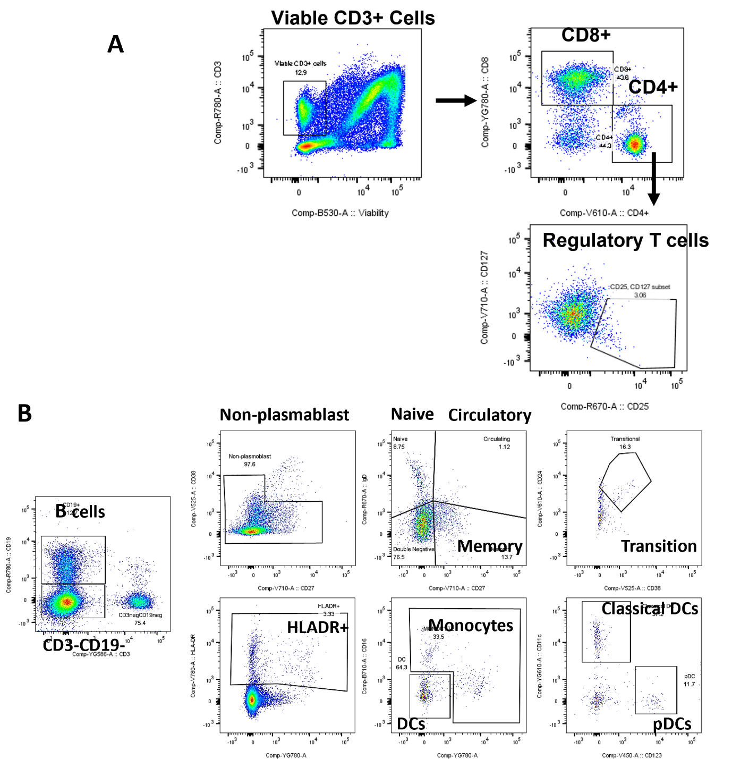

Figure S2. (A) gating strategy used to characterize CD8 and CD4 T cells and regulatory T cells based on the expression of CD3, CD8, CD4, CD25 and CD127. (B) gating strategy employed to identify monocytes and the different compartments of DCs and B cells.

